

NATIONAL INSTITUTE OF TECHNOLOGY KARNATAKA

SURATHKAL, MANGALORE - 575 025

Course Code – CS111

Course Name – Computer Programming Lab

Lab - 08

Date – August 10, 2021

Submitted To

Marwa Mohiddin Ma’am

Department of Computer Science and Engineering

National Institute of Technology Karnataka, Surathkal

Submitted By

Md Rakib Hasan

Roll – 201CS132

Department of Computer Science and Engineering

**Files and file operations**

**Question – 1**

Program to read data from the keyboard; write it in a file called DATA.txt. Again read the same data from the file and display it on the screen.

**Answer**

#include <stdio.h>

#include <stdlib.h>

#include <string.h>

int main()

{

    FILE *fp;

    char name[20], line[50];

    int i, n, roll;

    fp = fopen("DATA.txt", "w");

    if (fp == NULL)

    {

        printf("An error occured");

        exit(1);

    }

    else

    {

        printf("Total student: ");

        scanf("%d", &n);

        for (i = 0; i < n; i++)

        {

            printf("Enter roll: ");

            scanf("%d", &roll);

            printf("Enter name: ");

            gets(name);

            fgets(name, 20, stdin);

            name[strcspn(name, "\n")] = 0;

            fprintf(fp, "%d %s\n", roll, name);

            printf("\n");

        }

        fclose(fp);

    }

    fp = fopen("DATA.txt", "r");

    if (fp == NULL)

    {

        printf("An error Occured");

    }

    else

    {

        i = 0;

        printf("Showing info from file: \n");

        while (i < n)

        {

            fgets(line, 50, fp);

            printf("%s", line);

            i++;

        }

        fclose(fp);

    }

    return 0;

}

**Output**

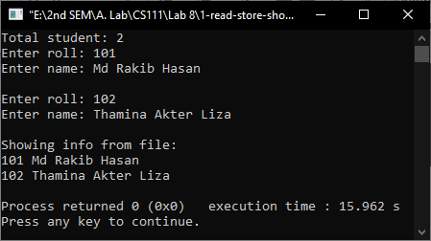

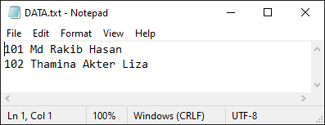

**Question – 2**

A file named DATA.txt contains a series of integer numbers. Write a program to read these numbers and then write all odd numbers to a file to be called ODD and all even numbers to a file to be called EVEN.

**Answer**

#include <stdio.h>

int main()

{

    FILE *fp, *even, *odd;

    int num;

    fp = fopen("DATA.txt", "r");

    even = fopen("EVEN.txt", "w");

    odd = fopen("ODD.txt", "w");

    if (fp == NULL || even == NULL || odd == NULL)

    {

        printf("An error occured");

    }

    else

    {

        while (!feof(fp))

        {

            fscanf(fp, "%d", &num);

            if (num % 2 == 0)

            {

                fprintf(even, "%d\n", num);

            }

            else

            {

                fprintf(odd, "%d\n", num);

            }

        }

    }

    fclose(fp);

    fclose(even);

    fclose(odd);

    return 0;

}

**Input**

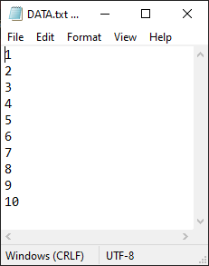

**Output**

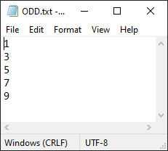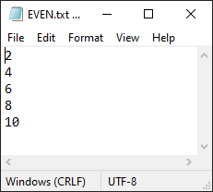

Question – 3

Copy the content of one file into another

**Answer**

#include <stdio.h>

int main()

{

    FILE *fp_in, *fp_out;

    char line[50];

    fp_in = fopen("Input.txt", "r");

    fp_out = fopen("Output.txt", "w");

    if (fp_in == NULL || fp_out == NULL)

    {

        printf("An error occured");

    }

    else

    {

        while (!feof(fp_in))

        {

            fgets(line, 50, fp_in);

            fprintf(fp_out, "%s", line);

        }

    }

    fclose(fp_in);

fclose(fp_out);

    return 0;

}

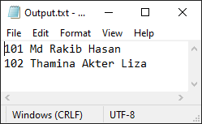**Input and Output**

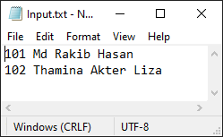

**Question – 4**

Program to append the content of a file at the end of another file without using append mode

**Answer**

#include <stdio.h>

#include <stdlib.h>

int main()

{

    FILE *fp_in, *fp_out;

    char line[100];

    fp_in = fopen("Input.txt", "r");

    fp_out = fopen("final.txt", "r+");

    if (fp_in == NULL || fp_out == NULL)

    {

        printf("An error occured");

        exit(1);

    }

    else

    {

        fseek(fp_out, 0, SEEK_END);

        while (!feof(fp_in))

        {

            fgets(line, 100, fp_in);

            fprintf(fp_out, "%s", line);

        }

    }

    fclose(fp_in);

    fclose(fp_out);

    return 0;

}

**Input and Output**

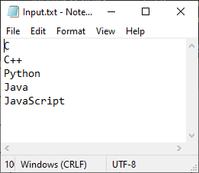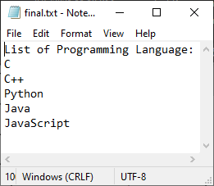

**Question – 5**

Program to find the size of file using file handling function

**Answer**

#include <stdio.h>

#include <stdlib.h>

int main()

{

    FILE *fp;

    fp = fopen("DATA.txt", "r");

    if (fp == NULL)

    {

        printf("An error occured");

        exit(1);

    }

    else

    {

        fseek(fp, 0, SEEK_END); //moving pointer to end

        printf("Size = %ld bytes", ftell(fp));

    }

    fclose(fp);

    return 0;

}

**Input and Output**

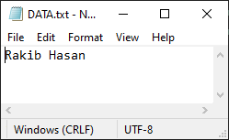

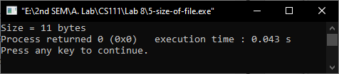

**Question – 6**

Program to find the number of lines in a text file

**Answer**

#include <stdio.h>

#include <stdlib.h>

int main()

{

    FILE *fp;

    char ch;

    int count = 1;

    fp = fopen("DATA.txt", "r");

    if (fp == NULL)

    {

        printf("An error occured");

        exit(1);

    }

    else

    {

        while (!feof(fp))

        {

            ch = fgetc(fp);

            if (ch == '\n')

            {

                count++;

            }

        }

    }

    fclose(fp);

    printf("Total Line = %d", count);

    return 0;

}

**Input and Output**

